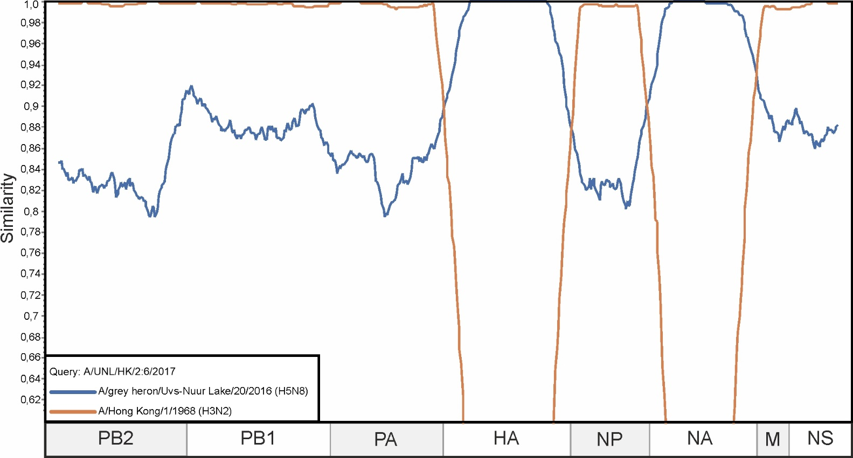

**Supplementary Figure S2.** A similarity plot analysis (window = 600, step = 10) was performed. The genome of A/UNL/HK/2:6/2017 was selected as the query sequence. The x-axis shows the nucleotide position in the alignment and the y-axis shows the percentage similarity between the query sequence and two other selected viruses. Coordinates were found for each segment in the alignment and the segments were plotted on the x-axis of the similarity plot